**Create an ASP.NET Web Forms Application to Display the UI for Managing the School Database**

**Git hub link:** [**https://github.com/pravallikaadineni/mainprojects.git**](https://github.com/pravallikaadineni/mainprojects.git)

**Step 1:**

* Create a new project in visual studio
* Select Asp.Net web application and then select web forms
* Create a class library
* Add library reference to the web application

**Step 2:**

* Add a web form and add required fields as shown in figure
* Drag and drop the required fields

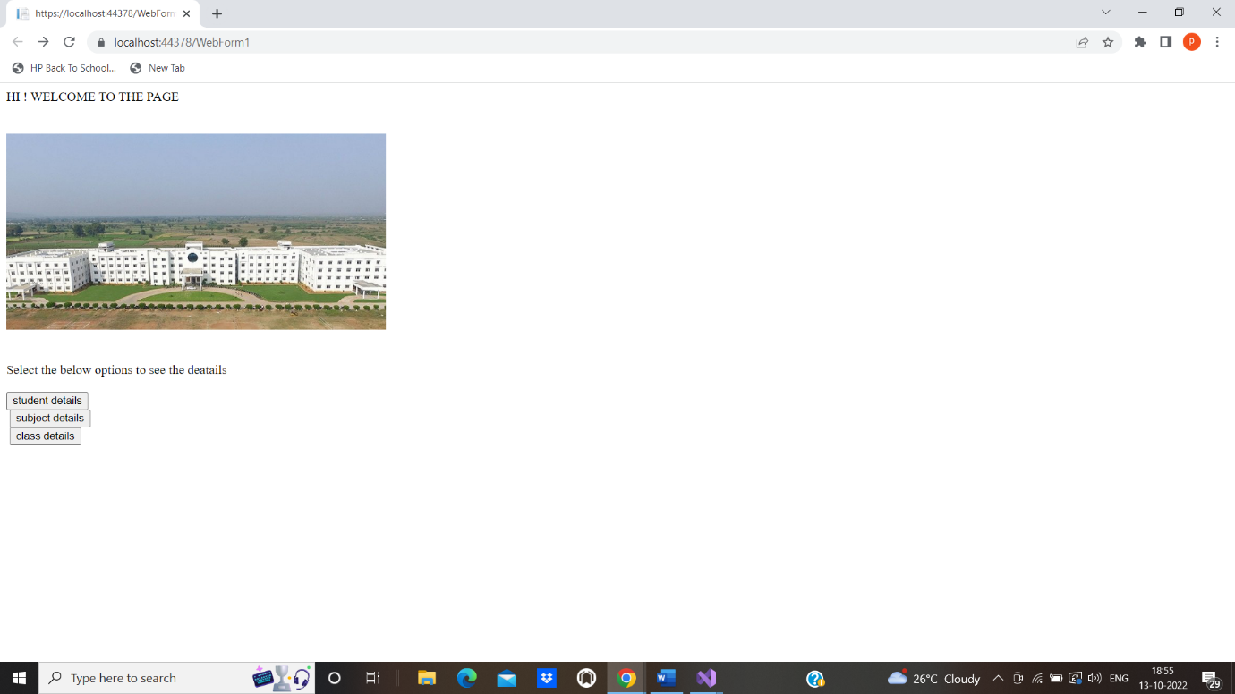

**Step 3:**

* Write respective code in the button fields
* Open the web app. apsx and run the application

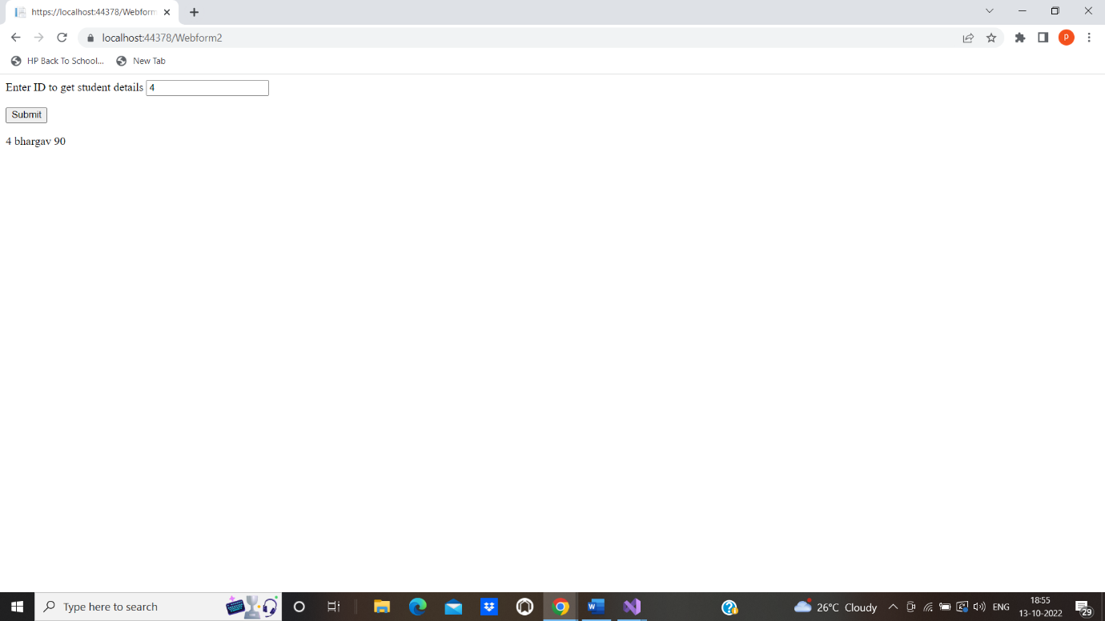

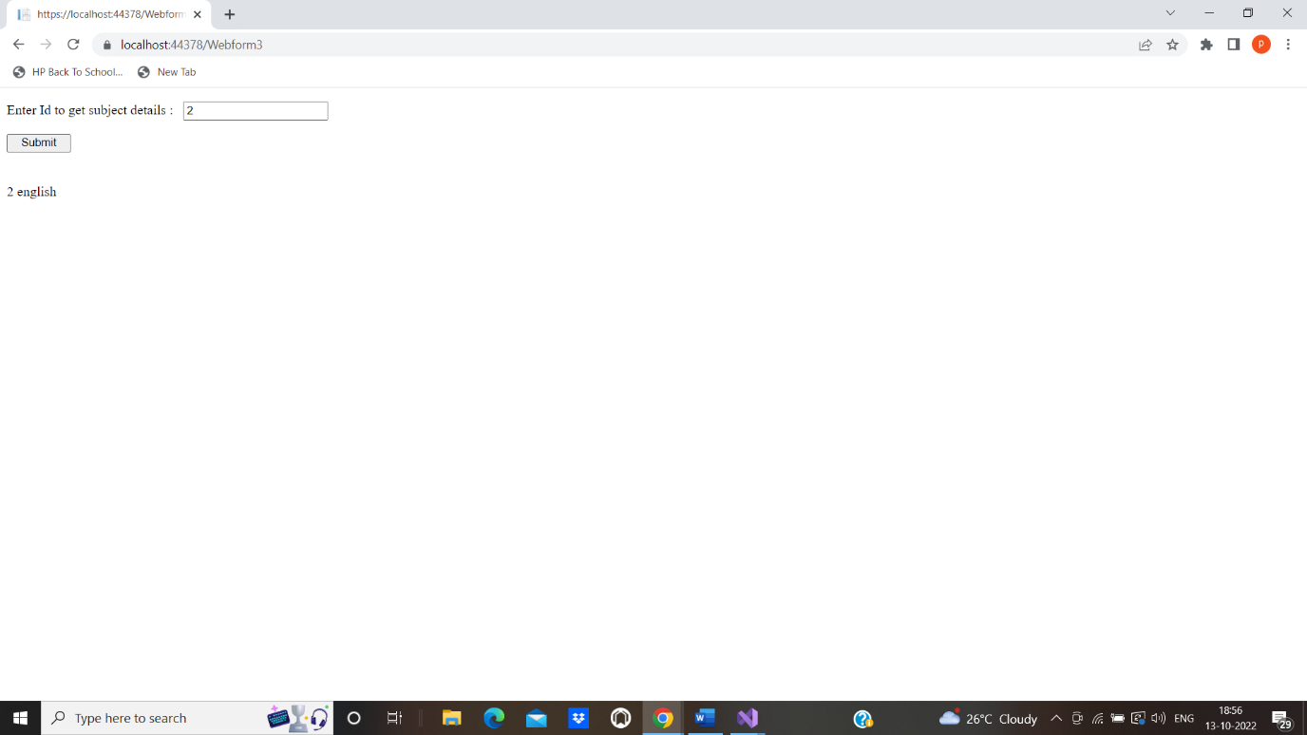

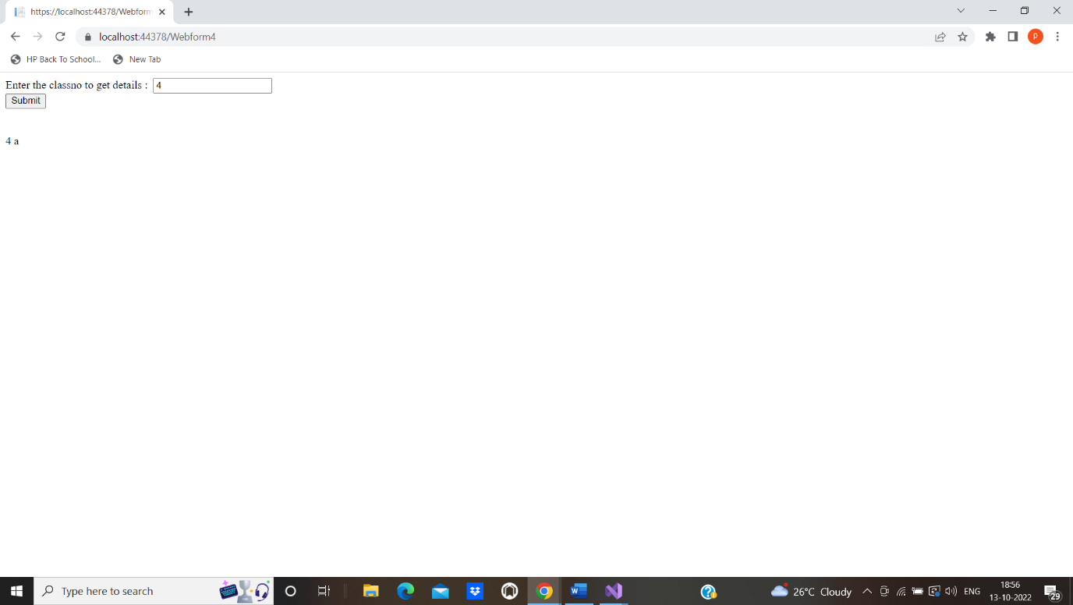

**Step 4**:

Pushing the code to your GitHub repositories

Open your command prompt and navigate to the folder where you have created your files.

**cd <folder path>**

Initialize your repository using the following command:

**git init**

Add all the files to your git repository using the following command:

**git add .**

Commit the changes using the following command:

**git commit -m “Changes have been committed.”**

Push the files to the folder you created initially using the following command:

**git push -u origin master**